EXPT13 Implementation and Performance Evaluation of a CNN Based Deep Learning Model for IoE Edge Applications

Objective
- To implement a Convolutional Neural Network (CNN) model using PyTorch in Google Colab.
- To train the CNN model using the MNIST handwritten digit dataset.
- To classify handwritten digits into 10 classes (0–9).
- To evaluate the model performance based on test accuracy and training time.
- To understand the application of deep learning models in edge-based IoE (Internet of Everything) applications.
Procedure
- Open Google Colab and create a new Python notebook.
- Import the required libraries, including PyTorch, Torchvision, and the time module.
- Check GPU availability and select the appropriate computing device (GPU or CPU).
- Set the hyperparameters: batch size to 64, epochs to 5, and learning rate to 0.001.
- Load the MNIST dataset, which contains handwritten digit images, and apply tensor conversion and normalization.
- Divide the dataset into training and testing sets using the built-in MNIST dataset.
- Define the CNN architecture using two convolutional layers, ReLU activation functions, max-pooling layers, and fully connected layers.
- Initialize the model, cross-entropy loss function, and Adam optimizer.
- Train the CNN model for five epochs by performing forward propagation, loss calculation, backpropagation, and weight updates.
- Measure and display the total training time and loss for each epoch.
- Evaluate the trained model using the 10,000 test images and calculate the classification accuracy.
12.Record the final test accuracy and training time to assess the model's performance.
Program:
# =======================================================
# CNN Digit Classification with Metrics & Confusion Matrix
# ======================================================
import torch
import torch.nn as nn
import torch.optim as optim
from torch.utils.data import DataLoader
from torchvision import datasets, transforms
import time
# For plotting and confusion matrix
import matplotlib.pyplot as plt
import seaborn as sns
from sklearn.metrics import confusion_matrix
import numpy as np
# 1. Check for GPU availability in Colab
device = torch.device("cuda" if torch.cuda.is_available() else "cpu")
print(f"Using device: {device}")
# 2. Hyperparameters
BATCH_SIZE = 64
EPOCHS = 5
LEARNING_RATE = 0.001

# 3. Data Transformations & Loading MNIST
transform = transforms.Compose([
transforms.ToTensor(),
transforms.Normalize((0.1307,), (0.3081,)) # Mean and std of MNIST
])
train_dataset = datasets.MNIST(root='./data', train=True, download=True, transform=transform)
test_dataset = datasets.MNIST(root='./data', train=False, download=True, transform=transform)
train_loader = DataLoader(dataset=train_dataset, batch_size=BATCH_SIZE, shuffle=True)
test_loader = DataLoader(dataset=test_dataset, batch_size=1000, shuffle=False)
# 4. Define the CNN Architecture
class DigitCNN(nn.Module):
def __init__(self):
super(DigitCNN, self).__init__()
self.features = nn.Sequential(
nn.Conv2d(1, 32, kernel_size=3, padding=1), # Output: 32x28x28
nn.ReLU(),
nn.MaxPool2d(kernel_size=2, stride=2), # Output: 32x14x14
nn.Conv2d(32, 64, kernel_size=3, padding=1),# Output: 64x14x14
nn.ReLU(),
nn.MaxPool2d(kernel_size=2, stride=2) # Output: 64x7x7
)
self.classifier = nn.Sequential(
nn.Flatten(),
nn.Linear(64 * 7 * 7, 128),
nn.ReLU(),
nn.Dropout(0.25),
nn.Linear(128, 10) # 10 classes (0-9)
)

def forward(self, x):
x = self.features(x)
x = self.classifier(x)
return x

# Initialize model, loss function, and optimizer
model = DigitCNN().to(device)
criterion = nn.CrossEntropyLoss()
optimizer = optim.Adam(model.parameters(), lr=LEARNING_RATE)

# Track metrics for plotting
epoch_losses = []
epoch_accuracies = []

# 5. Training & Evaluation per Epoch Loop
print("\nStarting Training...")
start_time = time.time()

for epoch in range(EPOCHS):
model.train()
running_loss = 0.0
for data, target in train_loader:
data, target = data.to(device), target.to(device)
optimizer.zero_grad()
output = model(data)
loss = criterion(output, target)
loss.backward()
optimizer.step()
running_loss += loss.item()
avg_train_loss = running_loss / len(train_loader)
epoch_losses.append(avg_train_loss)
# Evaluate test accuracy at the end of each epoch
model.eval()
correct = 0
total = 0
with torch.no_grad():
for data, target in test_loader:
data, target = data.to(device), target.to(device)
outputs = model(data)
_, predicted = torch.max(outputs.data, 1)
total += target.size(0)
correct += (predicted == target).sum().item()
epoch_acc = 100 * correct / total
epoch_accuracies.append(epoch_acc)

print(f"Epoch [{epoch+1}/{EPOCHS}] | Loss: {avg_train_loss:.4f} | Test Accuracy: {epoch_acc:.2f}%")
print(f"\nTraining finished in {time.time() - start_time:.2f} seconds.\n")
# 6. Final Evaluation & Collect All Predictions for Confusion Matrix
all_preds = []
all_targets = []
model.eval()
with torch.no_grad():
for data, target in test_loader:
data, target = data.to(device), target.to(device)
outputs = model(data)
_, predicted = torch.max(outputs.data, 1)
all_preds.extend(predicted.cpu().numpy())
all_targets.extend(target.cpu().numpy())
# 7. Plotting Epoch vs. Accuracy & Loss
plt.figure(figsize=(12, 4))
plt.subplot(1, 2, 1)
plt.plot(range(1, EPOCHS + 1), epoch_losses, marker='o', color='b')
plt.title('Epoch vs Training Loss')
plt.xlabel('Epoch')
plt.ylabel('Loss')
plt.grid(True)
plt.subplot(1, 2, 2)
plt.plot(range(1, EPOCHS + 1), epoch_accuracies, marker='o', color='g')
plt.title('Epoch vs Test Accuracy (%)')
plt.xlabel('Epoch')
plt.ylabel('Accuracy (%)')
plt.grid(True)
plt.tight_layout()
plt.show()
# 8. Plotting Confusion Matrix
cm = confusion_matrix(all_targets, all_preds)
plt.figure(figsize=(8, 6))
sns.heatmap(cm, annot=True, fmt='d', cmap='Blues', cbar=False,
xticklabels=range(10), yticklabels=range(10))
plt.title('Confusion Matrix (Digit Classification)')
plt.xlabel('Predicted Label')
plt.ylabel('True Label')
plt.show()

Output:
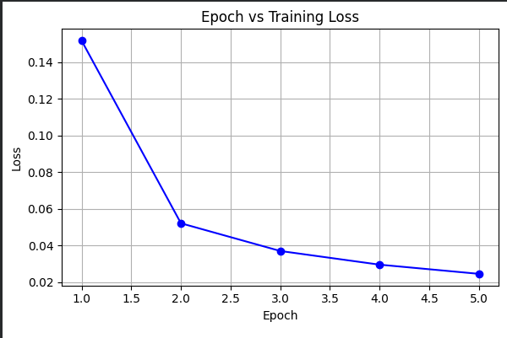

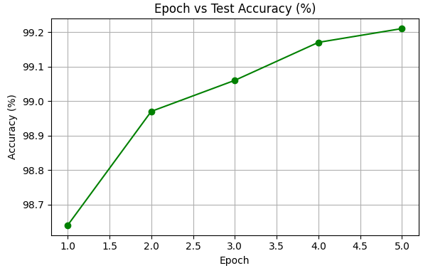

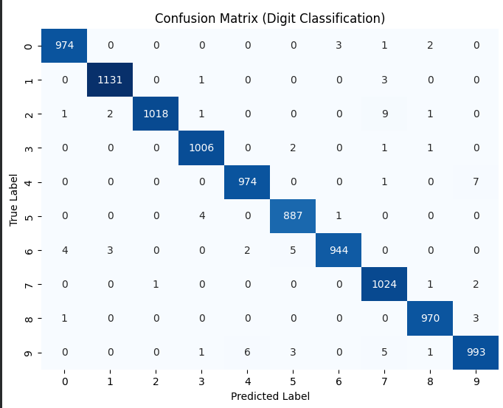

Table:
Table 1: Epoch-wise Test Accuracy Progression of the CNN Model
Epoch | Test accuracy
1 | 98.64%
2 | 98.97%
3 | 99.06%
4 | 99.17%
5 | 99.21%

Table 2: Per-Class Accuracy and Inference Performance of the CNN Model
Digital image | Accuracy | Testing Time
0 | 99.38% | 1.1225 milliseconds
1 | 99.65% | 1.1225 milliseconds
2 | 98.64% | 1.1225 milliseconds
3 | 99.60% | 1.1225 milliseconds
4 | 99.18% | 1.1225 milliseconds
5 | 99.44% | 1.1225 milliseconds
6 | 98.54% | 1.1225 milliseconds
7 | 99.61% | 1.1225 milliseconds
8 | 99.59% | 1.1225 milliseconds
9 | 98.41% | 1.1225 milliseconds

Result:
The CNN-based digit classification model was successfully implemented and evaluated using the MNIST dataset in Google Colab. The model achieved a test accuracy of 99.21% after 5 epochs. Training loss, test accuracy, and the confusion matrix were plotted to evaluate the model's performance.

